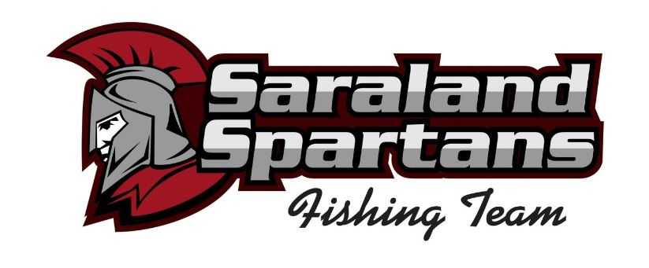
Standards of Conduct

The following list includes certain types of behaviors which can result in dismissal from the Saraland High School Fishing Team.

- Use of obscene, disruptive, hostile or abusive language while being a participant of the fishing team.
- Dishonesty or falsification of documents or records
- Abusing, threatening or intimidating behavior
- Possession, distribution, sale, transfer, or use of tobacco, alcohol or illegal drugs
- Unauthorized use or possession of weapons, firearms, or explosives
- Sexual or other harassment or discrimination
- Violating any applicable laws or regulations

I hereby acknowledge that I have read and understand the foregoing Standards of Conduct. I agree not to engage in any of the behaviors listed above. I understand that if I engage in any misbehavior, I may be removed from the Saraland High School Fishing Team.

_____________________________________________________ Date__________________________
Angler / Captain

____________________________________________________ Date ____________________________
Club Advisor

